Great Chart with Singleton Parish Council
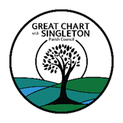
Founded in December 1894

Stronger Communities Committee

To be held on Tuesday 16th January 2024

at 5:15pm in the Parish Office
AGENDA

Apologies for Absence
To receive apologies for absence

Declarations of Interest

To hear declarations of interest, relating to

Disclosable Pecuniary Interests

Other Significant Interests

Other Interests

- Minutes of the previous meeting
To approve minutes of the previous meeting held on 28th November 2023 as a true record.

Community Fridge project

To receive an update and next steps for the project

To agree the purchase of the storage fridge

Cooking classes

To discuss ideas of how to provide cooking classes within the community.

Parish Awards

To discuss the introduction of a parish awards scheme

Date and venue of next meeting
To confirm date and venue of next meeting.

Signed
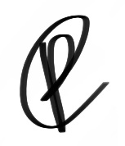
Paula Cowperthwaite
Deputy Clerk to Parish Council

